**Chapter 4**

**Applications of Derivatives**

**4.1 Related Rates**

**Section Exercises**

**For the following exercises, find the quantities for the given equation.**

1. Find at  and if 

Answer: 

3. Find at  and if  and

Answer: 

**For the following exercises, sketch the situation if necessary and used related rates to solve for the quantities.**

5. A 10-ft ladder is leaning against a wall. If the top of the ladder slides down the wall at a rate of 2 ft/sec, how fast is the bottom moving along the ground when the bottom of the ladder is 5 ft from the wall?

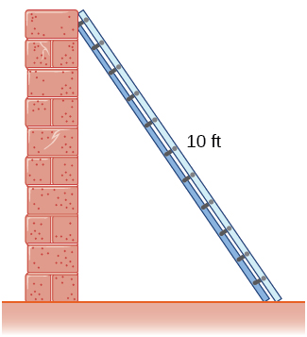

Answer: ft/sec

7. Two airplanes are flying in the air at the same height: airplane *A* is flying east at 250 mi/h and airplane *B* is flying north at  If they are both heading to the same airport, located 30 miles east of airplane *A* and 40 miles north of airplane *B*, at what rate is the distance between the airplanes changing?

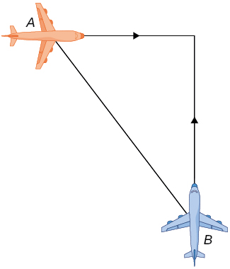

Answer: The distance is decreasing at

9. Two buses are driving along parallel freeways that are  apart, one heading east and the other heading west. Assuming that each bus drives a constant  find the rate at which the distance between the buses is changing when they are  apart, heading toward each other.

Answer: The distance between them shrinks at a rate of 

11. Using the previous problem, what is the rate at which the tip of the shadow moves away from the person when the person is 10 ft from the pole?

Answer:  ft/sec

13. Using the previous problem, what is the rate at which the shadow changes when the person is 10 ft from the wall, if the person is walking away from the wall at a rate of 2 ft/sec?

Answer: It grows at a rate  ft/sec

15. Using the previous problem, what is the rate at which the distance between you and the helicopter is changing when the helicopter has risen to a height of 60 ft in the air, assuming that, initially, it was 30 ft above you?

Answer: The distance is increasing at  ft/ sec

**For the following exercises, draw and label diagrams to help solve the related-rates problems.**

17. The volume of a cube decreases at a rate of  m/sec. Find the rate at which the side of the cube changes when the side of the cube is 2 m.

Answer:  m/sec

19. The radius of a sphere decreases at a rate of  m/sec. Find the rate at which the surface area decreases when the radius is 10 m.

Answer:  m2/sec

21. The radius of a sphere is increasing at a rate of 9 cm/sec. Find the radius of the sphere when the volume and the radius of the sphere are increasing at the same numerical rate.

Answer:  cm

23. A triangle has two constant sides of length 3 ft and 5 ft. The angle between these two sides is increasing at a rate of 0.1 rad/sec. Find the rate at which the area of the triangle is changing when the angle between the two sides is 

Answer: The area is increasing at a rate  ft/sec.

**For the following exercises, consider a right cone that is leaking water. The dimensions of the conical tank are a height of 16 ft and a radius of 5 ft.**

25. How fast does the depth of the water change when the water is 10 ft high if the cone leaks water at a rate of 10 ft3/min?

Answer: The depth of the water decreases at  ft/min.

27. If the water level is decreasing at a rate of 3 in./min when the depth of the water is 8 ft, determine the rate at which water is leaking out of the cone.

Answer: The volume is decreasing at a rate of 

29. A cylinder is leaking water but you are unable to determine at what rate. The cylinder has a height of 2 m and a radius of 2 m. Find the rate at which the water is leaking out of the cylinder if the rate at which the height is decreasing is 10 cm/min when the height is 1 m.

Answer: The water flows out at rate m/min.

31. A tank is shaped like an upside-down square pyramid, with base of 4 m by 4 m and a height of 12 m (see following figure). How fast does the height increase when the water is 2 m deep if water is being pumped in at a rate of  m/sec?

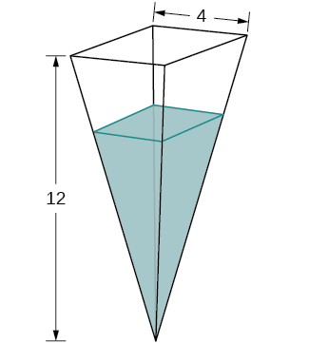

Answer:  m/sec

**For the following problems, consider a pool shaped like the bottom half of a sphere, that is being filled at a rate of 25 ft/min. The radius of the pool is 10 ft.**

33. Find the rate at which the depth of the water is changing when the water has a depth of 1 ft.

Answer:  ft/min

35. Gravel is being unloaded from a truck and falls into a pile shaped like a cone at a rate of 10 ft/min. The radius of the cone base is three times the height of the cone. Find the rate at which the height of the gravel changes when the pile has a height of 5 ft.

Answer:  ft/min

**For the following exercises, draw the situations and solve the related-rate problems.**

37. You are stationary on the ground and are watching a bird fly horizontally at a rate of m/sec. The bird is located 40 m above your head. How fast does the angle of elevation change when the horizontal distance between you and the bird is 9 m?

Answer: The angle decreases at 

39. A lighthouse, *L*, is on an island 4 mi away from the closest point, *P*, on the beach (see the following image). If the lighthouse light rotates clockwise at a constant rate of 10 revolutions/min, how fast does the beam of light move across the beach 2 mi away from the closest point on the beach?

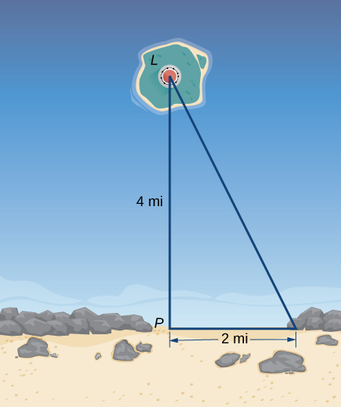

Answer: 

41. You are walking to a bus stop at a right-angle corner. You move north at a rate of 2 m/sec and are 20 m south of the intersection. The bus travels west at a rate of 10 m/sec away from the intersection – you have missed the bus! What is the rate at which the angle between you and the bus is changing when you are 20 m south of the intersection and the bus is 10 m west of the intersection?

Answer: The angle is changing at a rate of 

**For the following exercises, refer to the figure of baseball diamond, which has sides of 90 ft.**

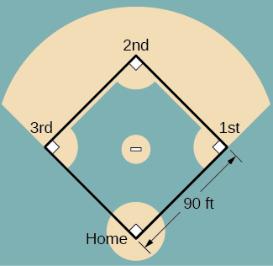

43.[**T]** A batter hits a ball toward second base at 80 ft/sec and runs toward first base at a rate of 30 ft/sec. At what rate does the distance between the ball and the batter change when the runner has covered one-third of the distance to first base? (*Hint*: Recall the law of cosines.)

Answer: The distance is increasing at a rate of  ft/sec.

45. **[T]** Runners start at first and second base. When the baseball is hit, the runner at first base runs at a speed of 18 ft/sec toward second base and the runner at second base runs at a speed of 20 ft/sec toward third base. How fast is the distance between runners changing 1 sec after the ball is hit?

Answer: The distance is decreasing at a rate of  ft/sec.

This file is copyright 2016, Rice University. All Rights Reserved.